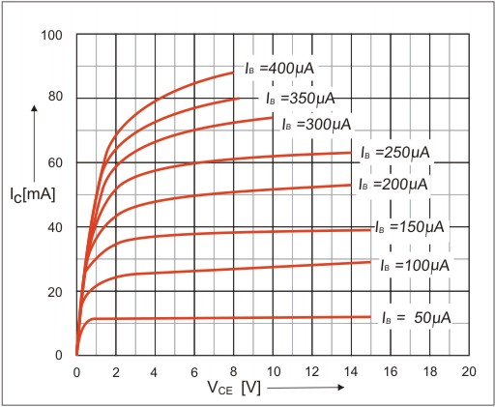

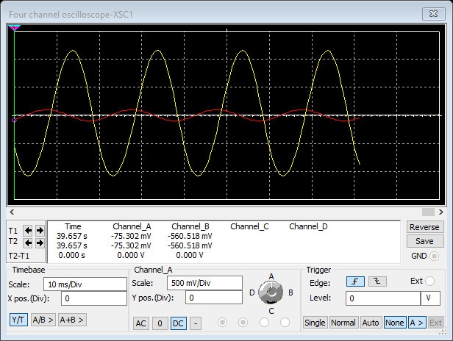

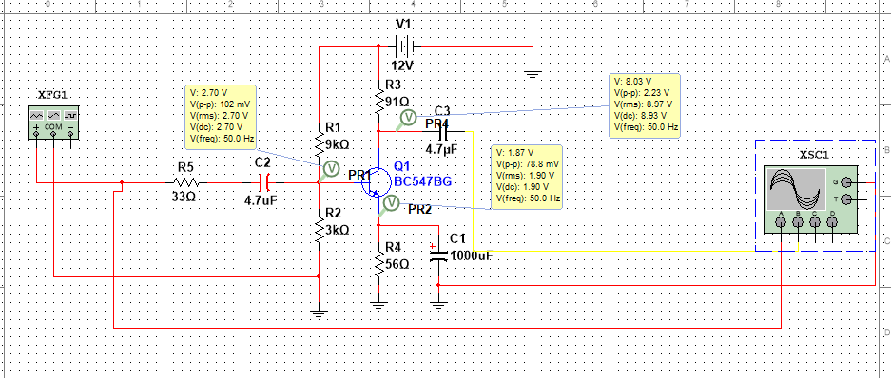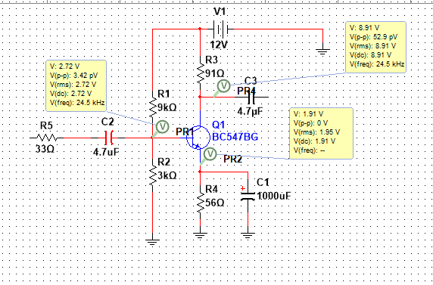

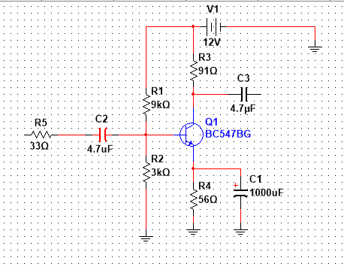

To bias Base, we use potential divider method. Then VB= 3 v. VBE=0.7 v

VE=2.7V We select RE such that IC = IE=40mA. RE=56Ω

We select VCE = 6v to keep the Q point in the middle.

$$Collector Resistor=\frac{3.7}{40}×1000 =91 Ω$$

IB= 150 µA

* BC 547 BG Transistor 1
* 3 kΩ Resistor
* 9 kΩ Resistor
* 91 Ω Resistor
* 56 Ω Resistor
* 33 Ω Resistor
* 4.7 µF Capacitors 2
* 1000 µF Capacitor